1. **Agenda**:
   1. Replacing in-memory authentication with JDBC (DB) authentication.
2. 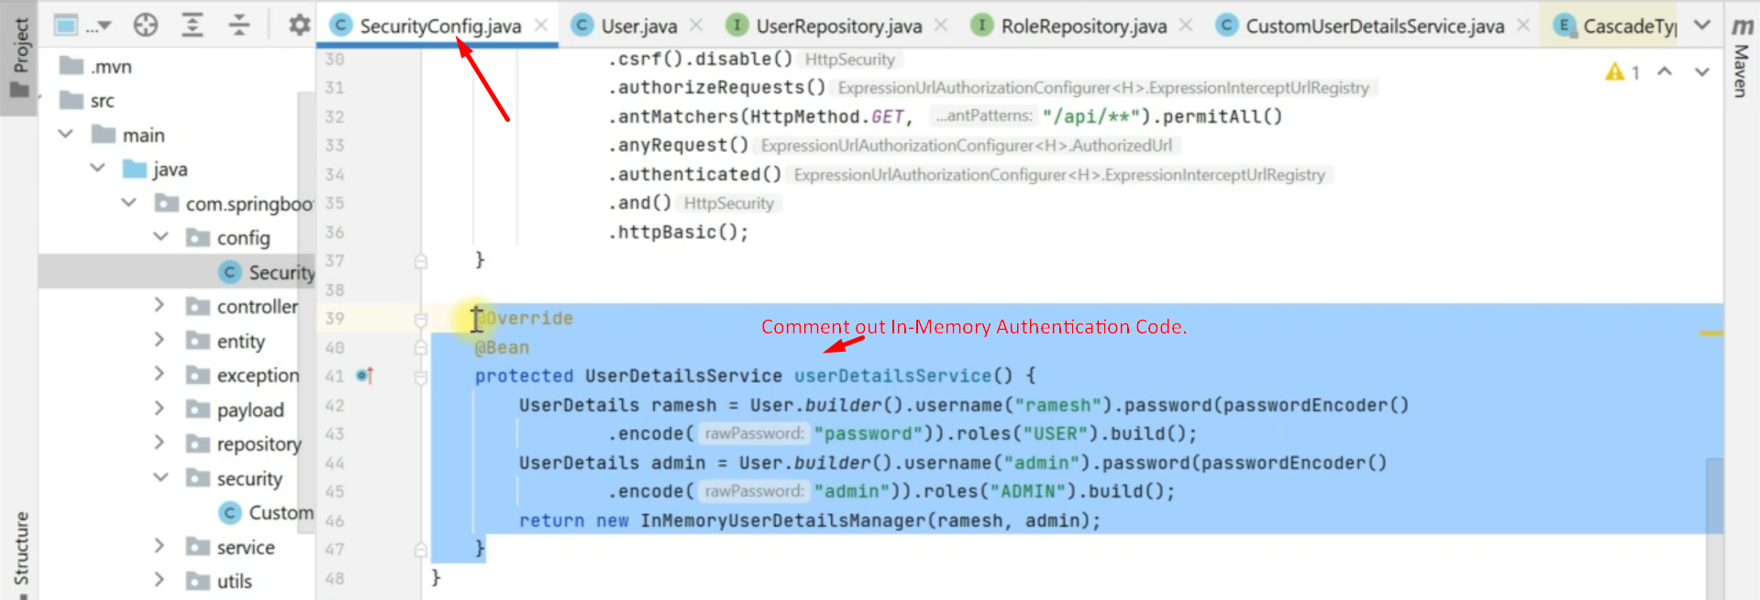
3. Steps:
   1. 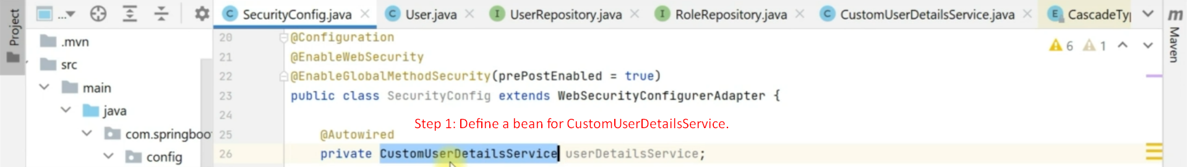
   2. 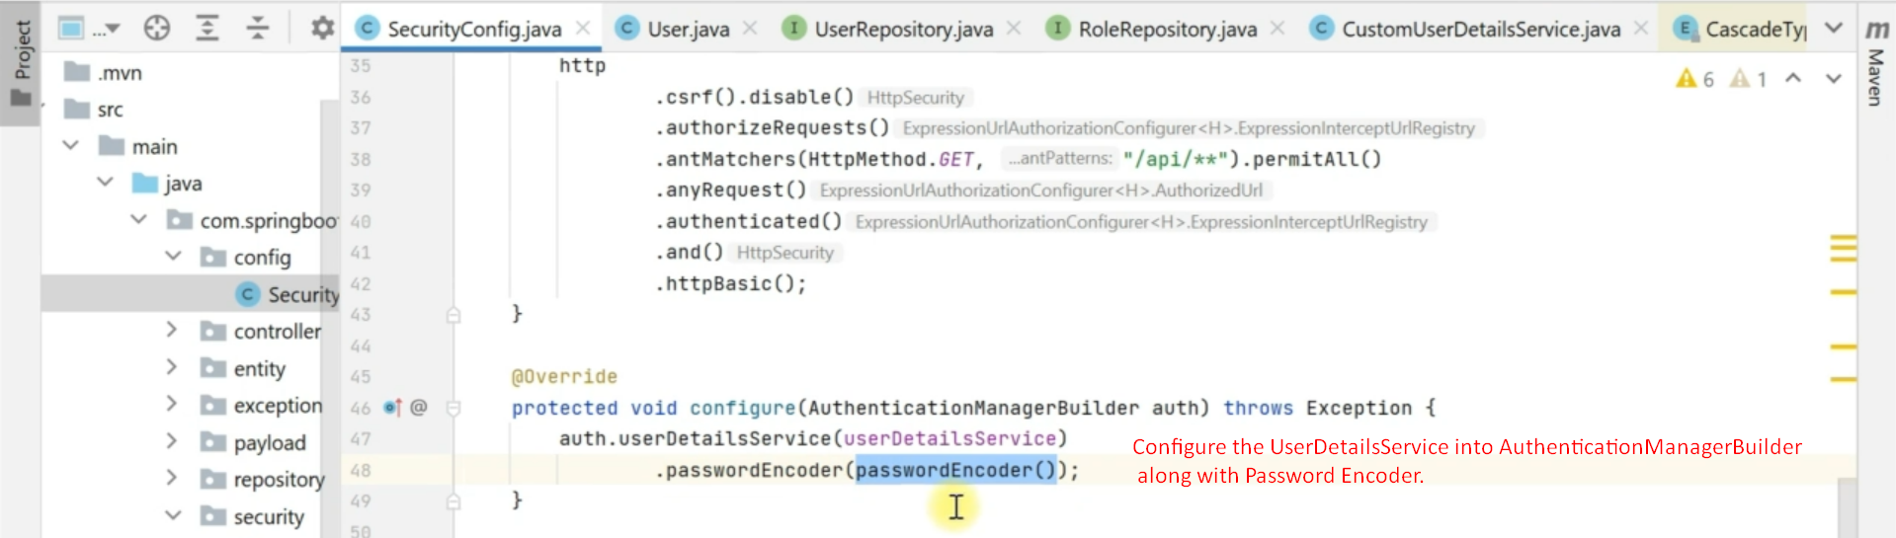
   3. Adding Users to DB.  
      Adding to user table.  
      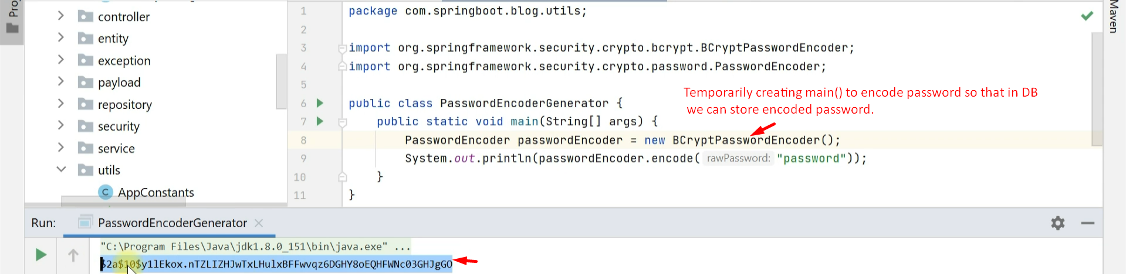  
      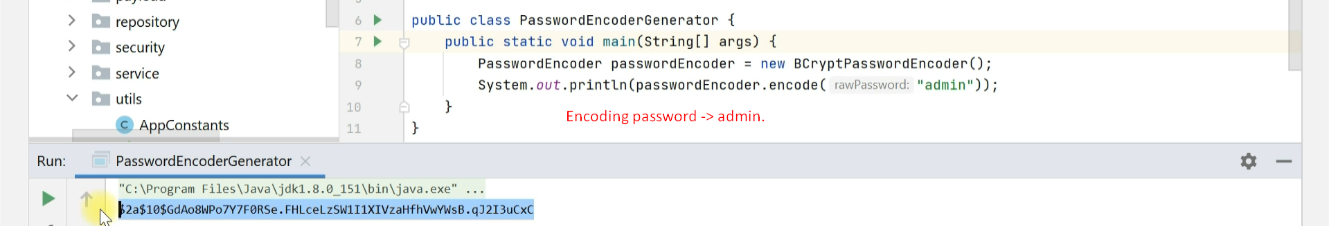  
      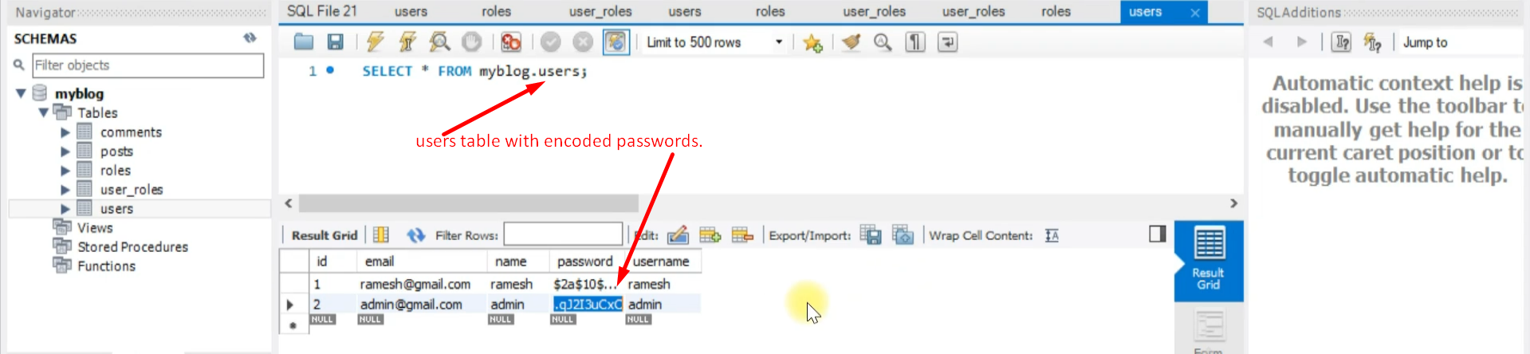  
        
      Inserting into roles table.  
      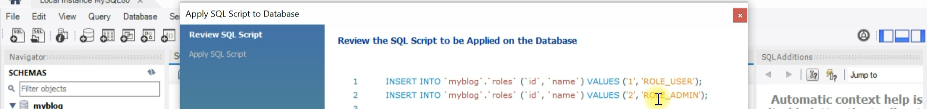

Inserting into user_roles table  
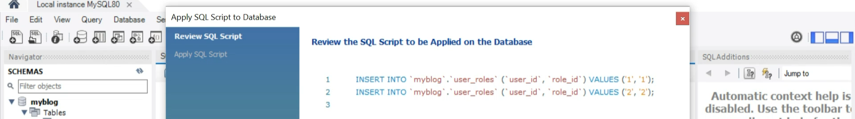

1. Now you can test your application as per the security configured by you.
2. **NOTE**: Each time, a user makes a request, he/she has to send credentials to authenticate means we don’t have still sign-in feature in RESTful API.  
   With sign-in feature, the user will send credentials only once to the sign-in REST API and it will return token and that token will be exchanged in all subsequent requests as authenticated user.